**Samba:**

* Samba is an open source and free software suite that provides file & printing services to SMB/CIFS clients (smb clients).
* Samba is a networking tool which allows Unix/Linux systems to share their directory and printing services to Windows system and vice a versa.
* Samba runs on OS other than Microsoft like UNIX, Linux, IBM, etc.
* It uses TCP/IP protocol (installed on host machines) for network communication.
* Samba name comes from SMB.
* Samba uses SMB protocol (Microsoft Windows client-server networking protocol) to communicate Unix/Linux servers to Windows clients.
* SMB (Server Message Block) and CIFS (Common Internet File System) are network file sharing protocols developed by Microsoft.

**Services provided by Samba:**

* Provides interoperability between UNIX/Linux servers and Windows based clients
* Allows to share one or more directory trees
* Allows to share printing services
* Assists clients with network browsing
* Authenticate clients logging onto windows domain

**SMB: Server Message Block Protocol**

* It is Microsoft Windows network file sharing protocol which allows to share files, printers, serial ports between computers.
* It is client server request-response protocol in which client makes a request (by sending commands [SMBs]) to server to allow access to resources.

**CIFS: Common Internet File System**

* CIFs is a network protocol which is commonly used in sharing files on LAN.
* It allows client to manipulate files just as they were on a local computer.

**Workgroup:**

Workgroup is a collection of computers that each maintain their own security information.

**Domain:**

Domain is a collection of computers where security is handled centrally. Domain controller takes care of it and it keeps information related to users like account name, encrypted password, authorized hours of use, groups the user belongs to and so on.

**Network Browsing:**

* When new servers are introduced in network or old ones are removed, user will not be able to recognize changes made.
* To overcome this problem, each server broadcast its presence. Clients listen for these broadcasts and build up browse list.
* Microsoft introduced WINS (Windows Internet Name Service) to overcome this problem.

**NFS: Network File System**

* NFS is protocol that uses client server architecture.
* It is a way of mounting Linux directories over the network.
* It allows to mount local file system over a network and remote hosts to interact with them as they are mounted locally on the same system.
* With the help of NFS, we can share data on a central server like all music collection on central server and accessible to all home PCs connected to network.
* NFS uses RPCs to route requests between client and server.

|  |  |  |
| --- | --- | --- |
| **Client OS** | **Server OS** | **NFS/Samba** |
| Linux | Linux | NFS |
| UNIX | UNIX | NFS |
| Linux | UNIX | NFS |
| Windows | Linux | Samba |

**RPC: Remote Procedure Call**

* It is a protocol that one program (client) can request a service from a program (server) located in another computer on a network without having to understand the network’s detail.
* It is called function call or subroutine call.

**Portmap/rpcbind:**

* Portmapper converts RPC program numbers into TCP/UDP protocol port numbers.
* It must be running to make RPC calls.
* As NFS uses RPCs to route requests between client and server and when RPC server is started, it will tell Portmap what port number is listening to and what program number it is prepared to serve.
* When client wishes to make RPC call to particular program number, it will first contact to Portmap on the server machine to determine TCP/UDP port to use.
* Portmap is replaced by rpcbind.
* rpcbind is a server that converts RPC program number into universal addresses.
* When client wishes to make RPC call to particular program number, it will first contact to rpcbind on the server machine to determine address where RPC requests should be sent.
* To display list of RPC programs and corresponding TCP/UDP numbers,

Command: rpcinfo -p

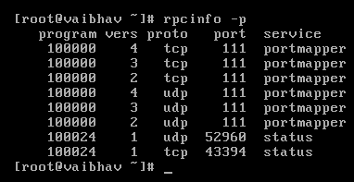

* To list out services and corresponding registered ports,

Command: cat /etc/services

**inetd/xinetd:**

* inetd: internet daemon
* xinetd: extended internet daemon
* inetd/xinetd runs in background and run by root at boot time.
* inetd/xinetd listens multiple ports and invokes only requested services.
* For an example, if user makes request for telnet service, inetd/xinetd will listen for port 23 (port number of telnet service) and inetd/xinetd will start in.telnetd service.
* It reduces load on system because service will run only when it is invoked rather than having to run continuously.
* xinetd is extended version of inetd and it is more secure than inetd.
* For this operation, inetd uses 2 configurations files:

/etc/services contains list of network services and corresponding port numbers.

/etc/inetd.conf contains list of network services that tells inetd which ports to listen and which service to run in response to request.

**Samba Server Configuration:**

* Make sure Linux system and Windows both are pingable from each end.
* samba rpm package is needed to configure samba.
* To check samba rpm package is installed or not,

Command: rpm -qa samba

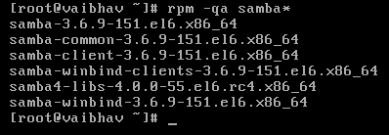

* If samba is not installed, Install samba rpm package,

yum install samba

* To install rpcbind service,

yum install rpcbind

To check status of rpcbind service,

service rpcbind status



* To install xinetd service,

yum install xinetd

To check status of rpcbind service,

service xinetd status



**chkconfig:** It is used to specify the run level of service.

* To run services automatically after reboot,

chkconfig rpcbind on

chkconfig xinetd on



* To create user,

Command: useradd vbhv

* Create directory named “data” to be shared with Windows client and create full access to that directory.

Command: mkdir /var/data

chmod 777 /var/data



* Open configuration file /etc/samba/smb.conf

Command: vi /etc/samba/smb.conf

* set the workgroup name to MYGROUP



* Add details of shared directory at the end of file

#add lines to share data directory

[data]

comment = personal share

path = /var/data

public = no

writable = yes

printable = no

browseable = yes

write test = vbhv

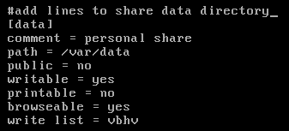

* Create samba user

Command: smbpassword -a vbhv



* Make smb service to run automatically after boot

Command: chkconfig smb on

* Change Workgroup to MYGROUP on Windows machine.

My Computer > Properties > Change settings > Computer Name > Change

Reboot the Windows system.

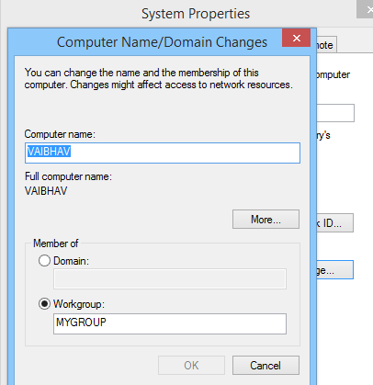

**Access Linux shares from Windows machine:**

* On Windows machine, ctrl+R > \\IP address of linux\

e.g., ctrl+R > \\192.168.5.2\

* Prompt will be appeared for credentials (samba user’s credentials). Enter valid credentials.

**Access Linux shares from Windows machine:**

* Make sure cifs-utlis is installed.



* Create a directory for mounting local storage.

Command: mkdir /media/windowsshare

* Mount the share.
* Command: mount -t cifs //Windows_IP/share_name target_folder_path -o username=user,password=pwd
* e.g.,

mount -t cifs //192.168.5.5/vbhv /media/windowsshare –o username=vbhvjari,password=8579

* Here,
* 192.168.5.5 is IP of windows machine
* vbhv is the shared folder
* /media/windowsshare is local directory for mounting
* vbhvjari is the username of windows machine
* 8579 is the password of that user



* Go to local directory and you will get shared file contents.

\

* To unmount mounted folder,

Command: umount /media/windowsshare